**CAPSTONE PROJECT**

**RESTAURANT MANAGEMENT SYSTEM**



**Project by,**

**S.GOPI KRISHNA**

**JAVA_FULLSTACK (FACEPREP)**

**43110270**

**B.E – CSE**

**1. INTRODUCTION**

FoodFrenzy is a web-based food ordering and management system developed using Java, Spring Boot, Maven, Thymeleaf, HTML, CSS, and MySQL, designed to simplify and automate the process of food product management and ordering. The application allows users to register, log in, search for food products, place orders, and view their order history, while administrators can manage users, add, update, and delete products, control stock levels, and monitor all orders through an admin dashboard. By replacing manual and traditional ordering methods, FoodFrenzy reduces errors, improves efficiency, and enhances user experience through a structured and user-friendly interface. The system follows a layered architecture with controllers, services, repositories, and entities, ensuring better maintainability, scalability, and separation of concerns. Overall, FoodFrenzy demonstrates a practical implementation of full-stack web development concepts and provides an efficient solution for managing food ordering operations in a real-world scenario.

**2. ABSTRACT**

FoodFrenzy is a full-stack web application developed to provide an efficient and user-friendly platform for online food ordering and management. The system is built using Java, Spring Boot, Maven, Thymeleaf, HTML, CSS, and MySQL, following a layered architecture that ensures modularity, scalability, and ease of maintenance. The application supports two main roles: users and administrators. Users can search for available food products, place orders, and view their order history, while administrators can manage users, add and update products, maintain stock levels, and monitor all customer orders through a centralized admin panel. By automating product management and order processing, FoodFrenzy minimizes manual effort, reduces errors, and improves overall operational efficiency. This project demonstrates the practical application of modern web development technologies and showcases how a robust backend integrated with an interactive frontend can deliver a reliable food ordering solution.

**3. OBJECTIVES OF THE PROJECT**

* To develop an easy-to-use online food ordering system for users.
* To allow users to search products, place orders, and view order history.
* To provide an admin panel for managing users and products.
* To maintain and update product stock efficiently.
* To track and manage all customer orders in one place.
* To reduce manual work and improve accuracy using a Spring Boot–based system.

**4.SCOPE**

The scope of the FoodFrenzy project includes online product management, stock maintenance, and order processing through a web-based application. It supports user and admin roles to ensure secure access and efficient system control. The system can be further extended with online payments, delivery tracking, and mobile application support in the future.

**5. TARGET USERS**

**Customers (Users)** Customers can register, log in, search for food products, place orders, view order history, and track their purchases easily through the application.

**Administrators (Admins)** Administrators manage the entire system, including adding and updating products, maintaining stock levels, managing users, and monitoring all customer orders from the admin dashboard.

**6.TECH STACK**

| **Category** | **Technology Used** | **Purpose / Description** |
| --- | --- | --- |
| Programming Language | Java | Core backend logic and business processing |
| Backend Framework | Spring Boot | Application framework for building scalable Java applications |
| Web Framework | Spring MVC | Handles HTTP requests and responses using MVC pattern |
| ORM Framework | Hibernate / JPA | Manages database operations and object–relational mapping |
| Frontend Technologies | JSP, HTML, CSS | Used for designing and rendering user interface |
| Database | MySQL | Relational database for storing hospital data |
| Build Tool | Maven | Dependency management and project build automation |
| IDE | Spring Tool Suite (STS) | Development environment for Spring Boot applications |
| Server | Embedded Tomcat | Runs the Spring Boot web application |

Table 1: Tech Stack

**7. SYSTEM REQUIREMENTS**

**HARDWARE REQUIREMENTS**

* **Processor:** Dual Core or higher
* **RAM:** Minimum 4 GB (Recommended 8 GB)
* **Hard Disk:** Minimum 5 GB free space
* **Display Resolution:** 1366 × 768 or higher
* **Internet Connection:** Required for development and deployment

**SOFTWARE REQUIREMENTS**

* **Operating System:** Windows 10 / Windows 11
* **Programming Language:** Java JDK 8 or above
* **Backend Framework**: Spring Boot 3.x
* **Web Framework:** Spring MVC (included with Spring Boot)
* **ORM Framework:** Hibernate / JPA (latest stable version)
* **Database**: MySQL Server 8.0 or above
* **IDE:** Spring Tool Suite (STS) 4.x
* **Build Tool**: Maven 3.6 or above
* **Application Server:** Embedded Apache Tomcat (comes with Spring Boot)
* **Frontend Technologies:** JSP, HTML5, CSS3
* **Web Browser:** Google Chrome (latest) / Microsoft Edge (latest)
* **API Testing Tool:** Postman (latest version)

**8.SYSTEM ARCHITECTURE**

The FoodFrenzy system follows a layered architecture using Spring Boot. Users and administrators interact with the application through a web interface built with HTML, CSS, and Thymeleaf. Requests are processed by controllers, business logic is handled in the service layer, and data is managed using JPA repositories connected to a MySQL database. This architecture ensures better separation of concerns, scalability, and easy maintenance.

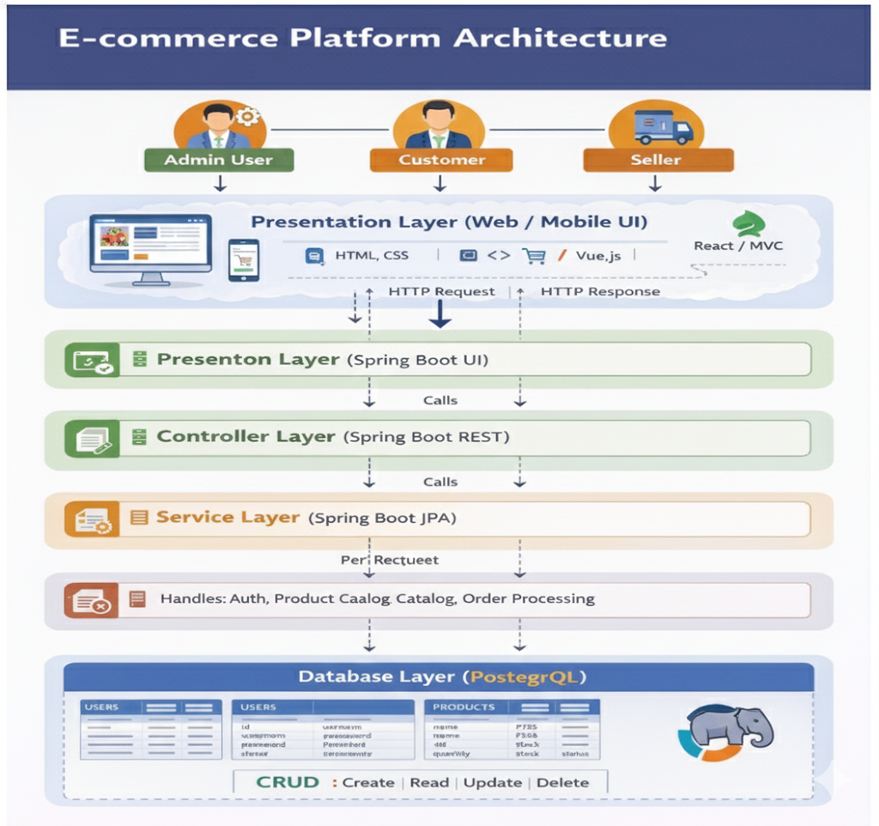

**9.SYSTEM WORKFLOW**

The user logs into the system and searches for available products. After selecting a product and quantity, the user places an order, and the system calculates and confirms the total amount. The order details are stored in the database and displayed in the user’s order history. Administrators manage products, users, and monitor all orders through the admin dashboard.

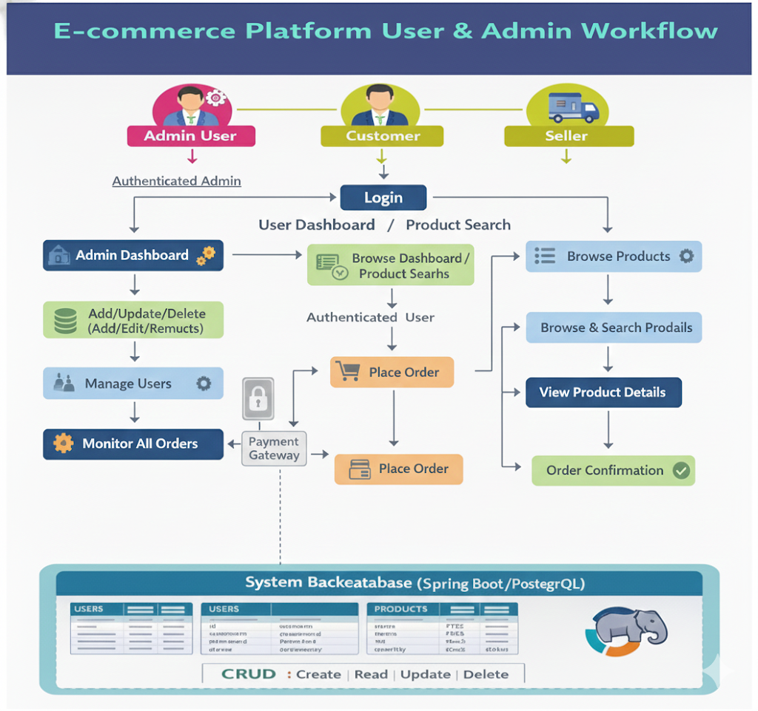

**10.DATABASE DESIGN**

The database is designed using a relational model to efficiently store and manage application data. It consists of core tables such as **Admin**, **Members (Users)**, **Product**, and **Orders**, each with clearly defined primary keys to ensure data integrity. Relationships are established between users and orders, allowing each order to be associated with a specific user, while products are linked to orders to track purchases. This structured design supports fast data retrieval, secure storage, and smooth interaction between different modules of the system.

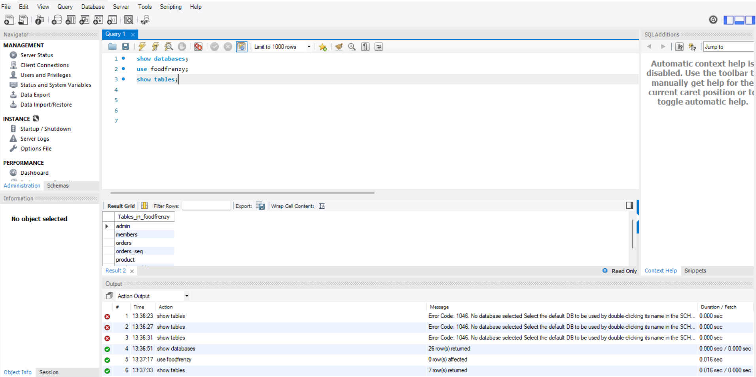

## **11. HTTP REQUEST METHODS & API DOCUMENTATION**

The Food Ordering Management System follows RESTful architecture principles and uses standard HTTP request methods to perform CRUD operations on system modules such as admins, users, products, and orders. Each endpoint is responsible for a specific operation and ensures smooth communication between the frontend and backend. Data is exchanged securely and efficiently, primarily using form data and server-rendered views.

**11.1** **API Mapping Table**

| Method | Endpoint | Description |
| --- | --- | --- |
| POST | /admin-login | Authenticates admin and redirects to admin dashboard |
| POST | /user-login | Authenticates user and allows access to ordering features |
| POST | /user/register | Registers a new user into the system |
| GET | /admin/services | Displays admin dashboard with users, products, and orders |
| GET | /product/search | Loads product search page for users |
| POST | /product/search | Searches product by name |
| POST | /addingProduct | Adds a new product (Admin only) |
| GET | /editProduct/{id} | Opens edit page for selected product |
| POST | /updatingProduct/{id} | Updates existing product details |
| GET | /deleteProduct/{id} | Deletes a product (Admin only) |
| POST | /user/product/order | Places an order for a selected product |
| GET | /order-success | Displays order success confirmation page |
| GET | /editUser/{id} | Opens edit page for a user (Admin only) |
| POST | /updatingUser/{id} | Updates user details |
| GET | /deleteUser/{id} | Deletes a user from the system |

**11.2 HTTP Methods Usage Summary**

* **POST** – Used to create new records such as patients, doctors, and appointments
* **GET** – Used to retrieve data from the system
* **PUT** – Used to update appointment status and doctor availability
* **DELETE** – Used to remove records (optional / future scope)

**12 PROJECT MODULES**

**12.1 Login Module**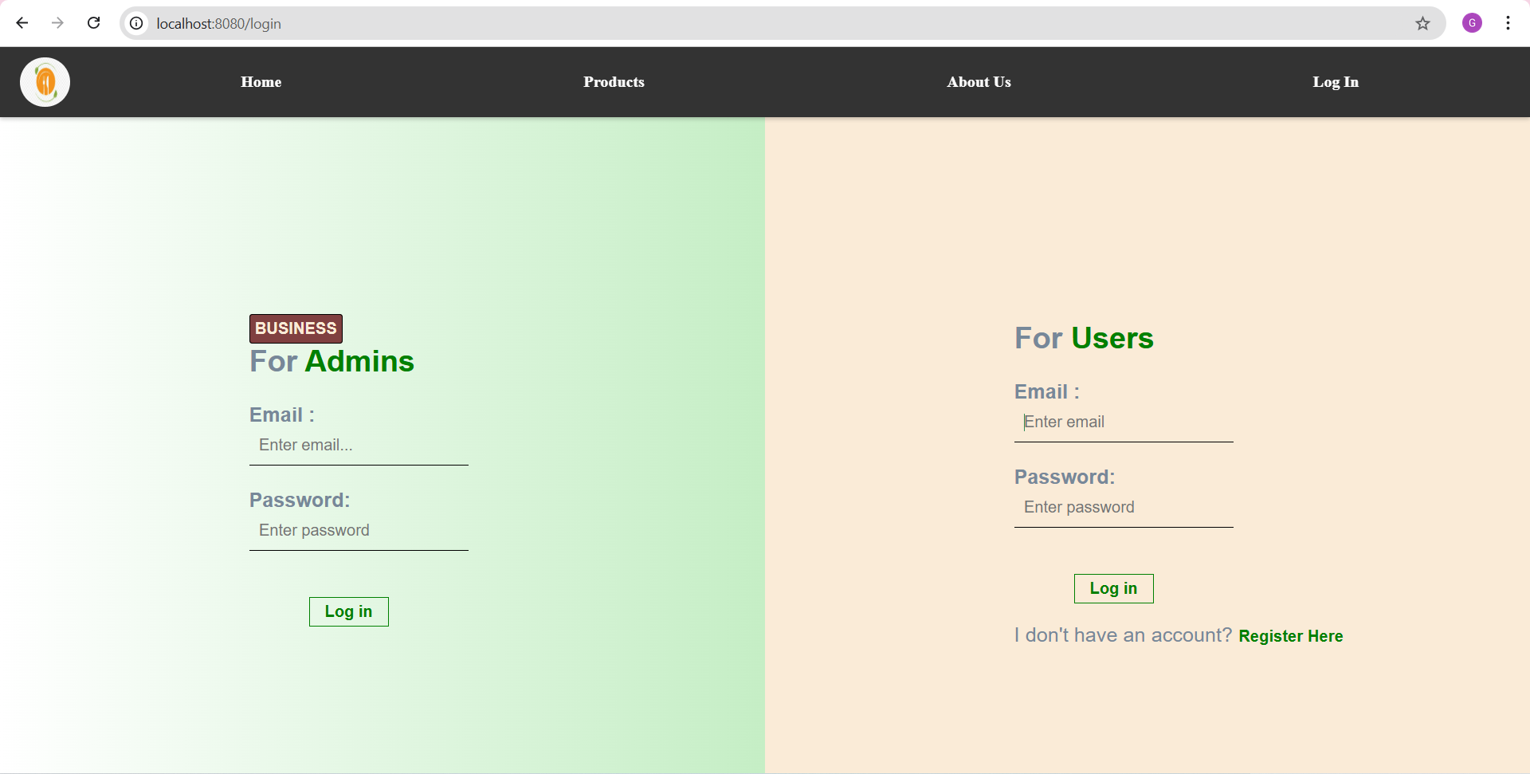

**12.2 Admin Module:**

The Admin Panel module acts as the central control unit of the FoodFrenzy system. It enables administrators to manage users, products, stock levels, and orders through a single dashboard. Admins can add, update, and delete product details, monitor inventory, view all customer orders, and manage user accounts. This module ensures smooth system administration, effective decision-making, and efficient overall operation of the application.

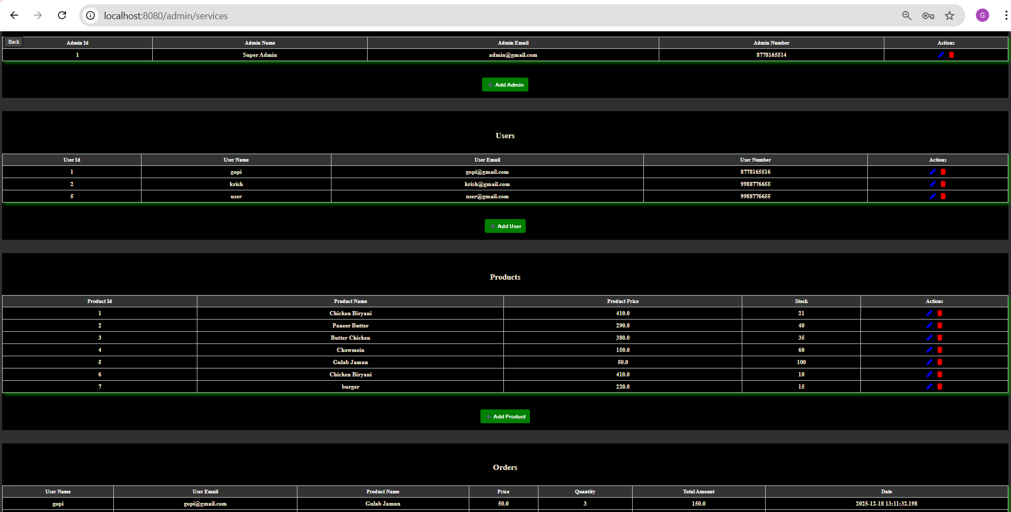



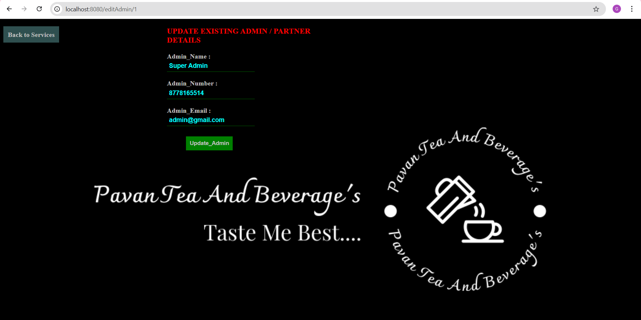

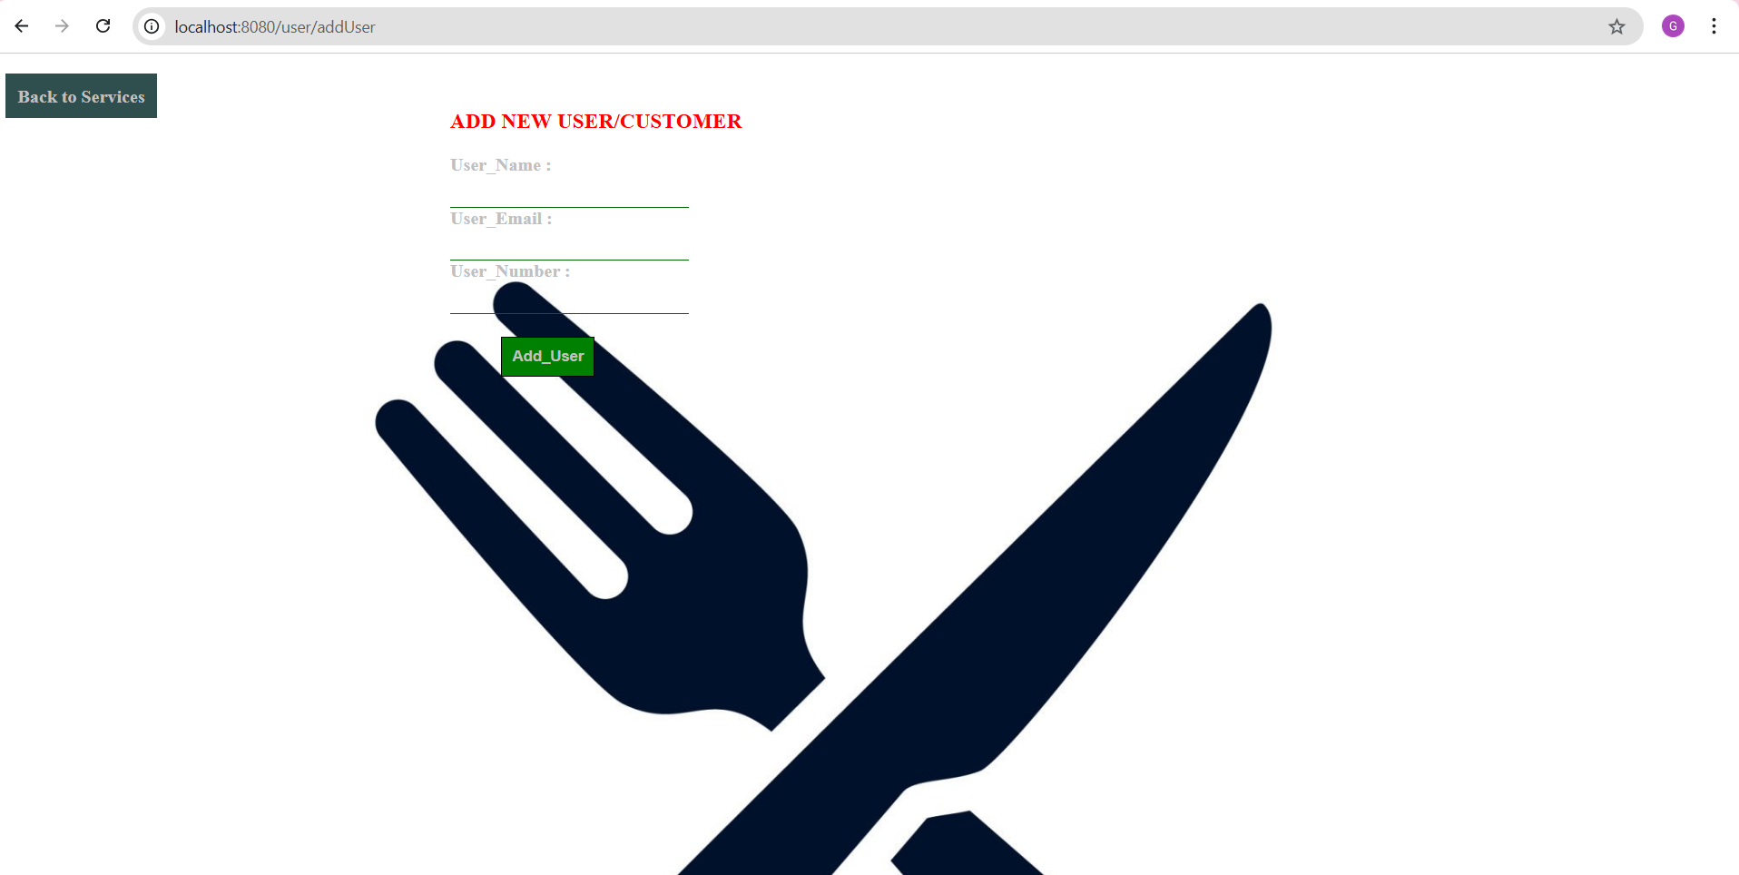

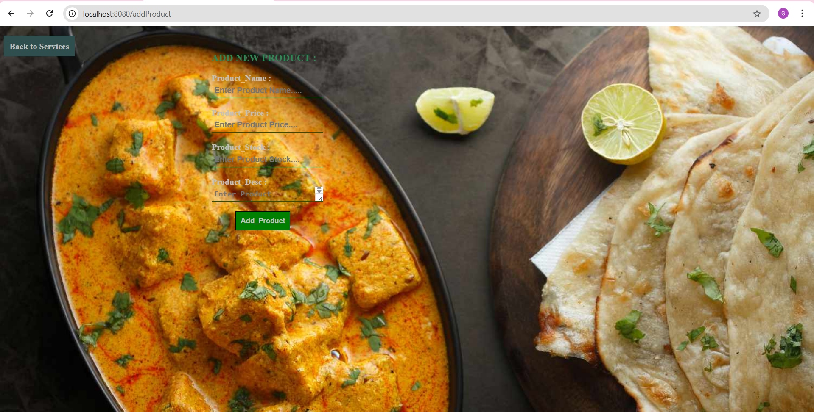

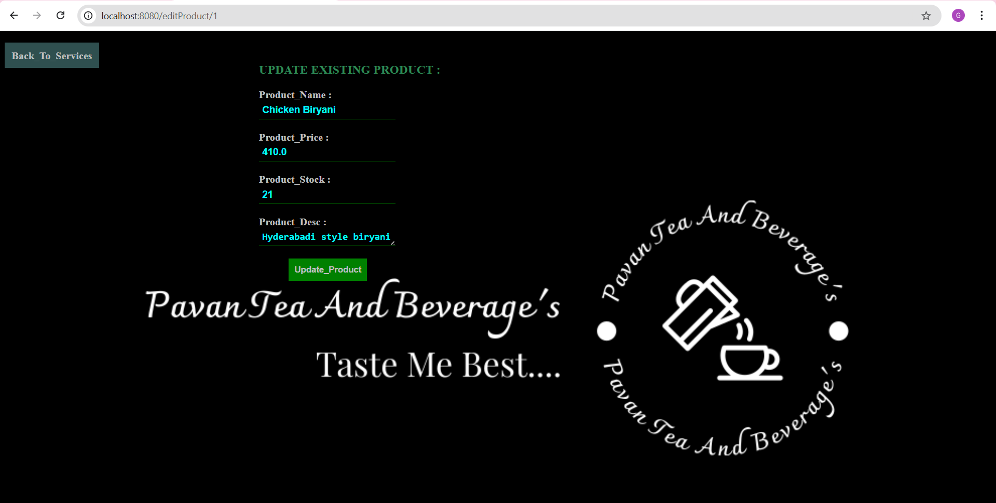

**12.3 Register Module:**

The User Registration module allows new users to create an account by providing essential details such as name, email, password, and contact number. The system validates user information to ensure secure and accurate registration. Once registered, users can log in to access features like product search, order placement, and order history, enabling a personalized and seamless experience within the FoodFrenzy platform.

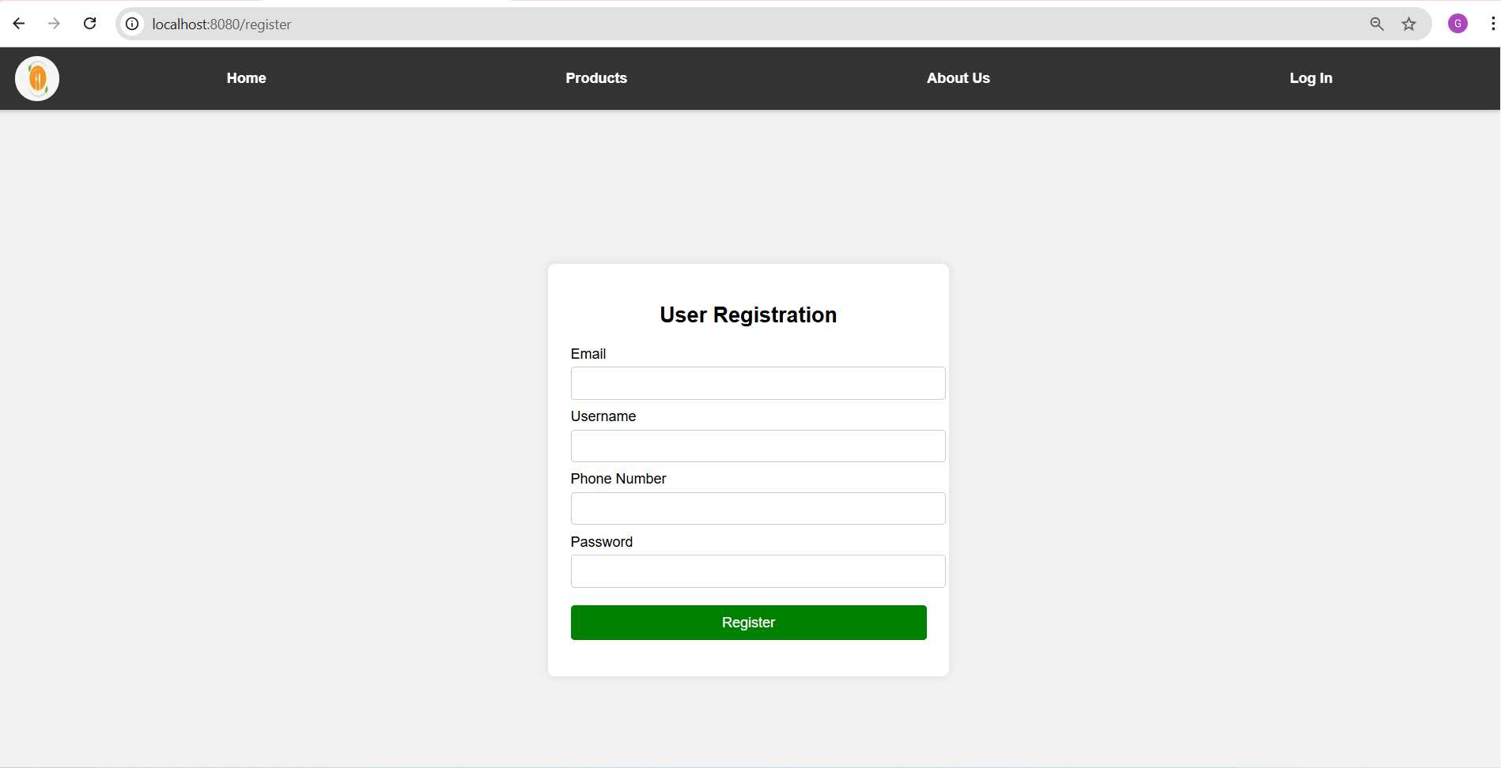

**12.4 Product Module:**

The Products module is responsible for managing all product-related information in the FoodFrenzy system. It allows administrators to add new products, update existing product details such as price, description, and stock, and remove products when required. This module ensures that accurate and up-to-date product information is available to users, supporting effective inventory management and a seamless ordering experience.

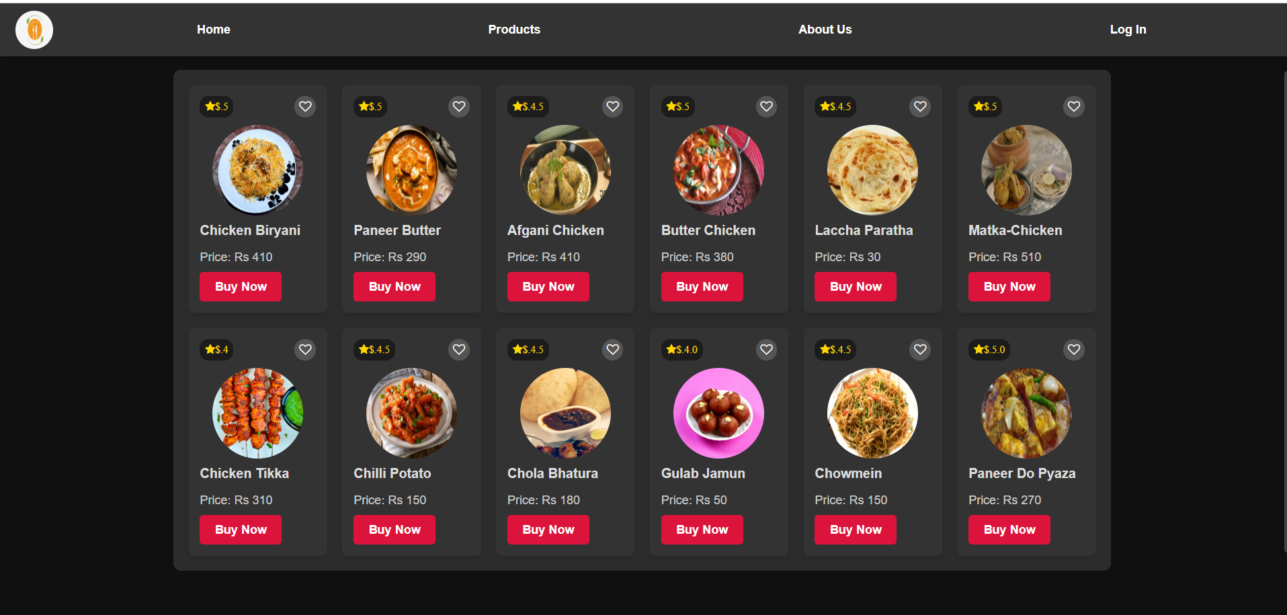

**12.5 User Home & Buy Product**

The User Home and Buy Product module provides a simple and interactive interface where users can search for available products, view product details, and place orders with ease. After logging in, users can browse products, select the desired quantity, and proceed to purchase. This module ensures a smooth shopping experience by displaying order confirmations and maintaining the user’s order history for future reference.

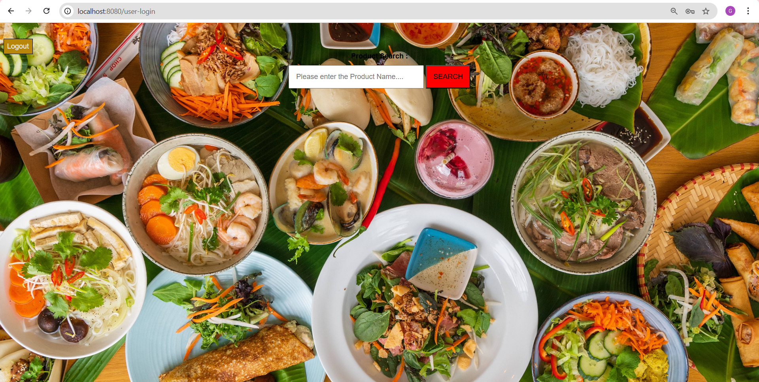

**12.6 Search And Order Product Module:**

The Search and Order Product module allows users to easily find food products by entering the product name and viewing relevant details such as price and availability. Once a product is selected, users can choose the required quantity and place an order instantly. The system automatically calculates the total amount and confirms the order, providing a smooth and user-friendly purchasing experience.

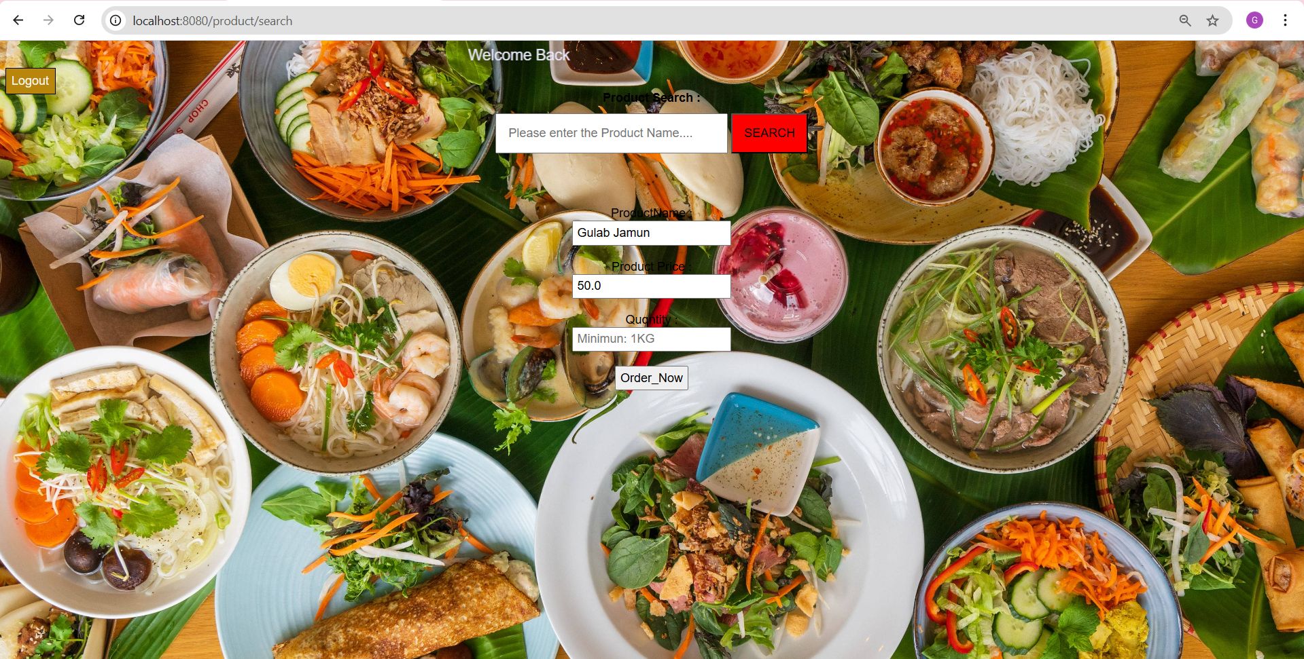

**12.7 Order Success Module:**

Your purchase has been successfully placed and is now being processed. We have received your order details, and our team will begin preparing it shortly. You can view your order information and total amount on this page, and we’ll ensure a smooth and timely service. Thank you for choosing **FoodFrenzy**—we hope you enjoy your meal!

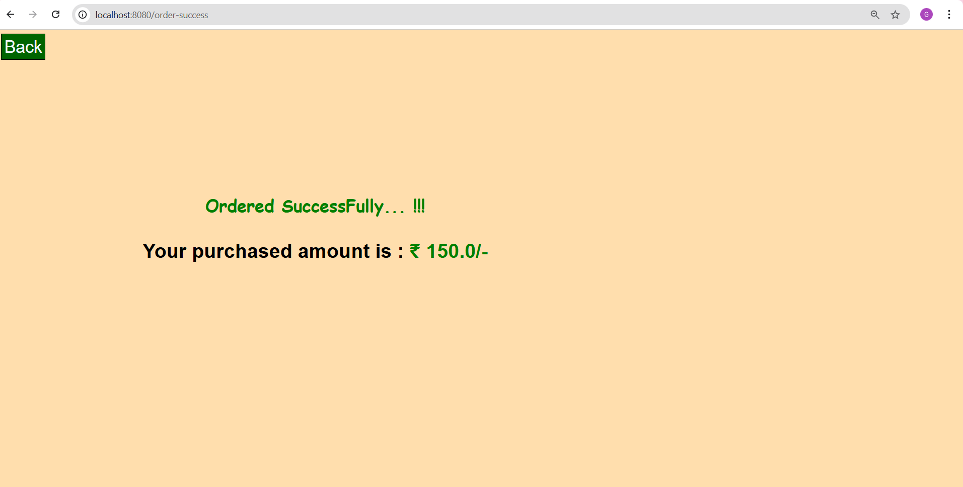

**12.8 About Module:**

FoodFrenzy is a user-friendly online food ordering and management platform designed to simplify the process of browsing products, managing orders, and handling inventory efficiently. Our goal is to bridge the gap between customers and food service providers by offering a reliable, secure, and easy-to-use system. With a focus on performance and scalability, FoodFrenzy empowers administrators to manage products, stock, and users effectively, while customers enjoy a smooth and convenient ordering experience.

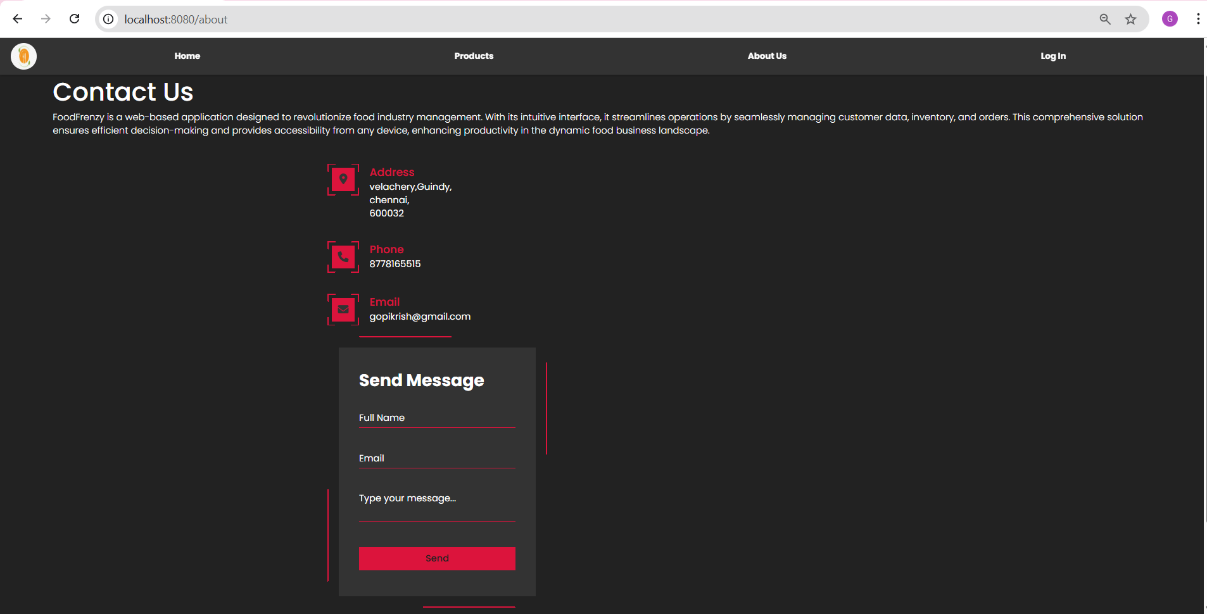

**13.DATABASE TABLES**

**13.1 Users Table:**

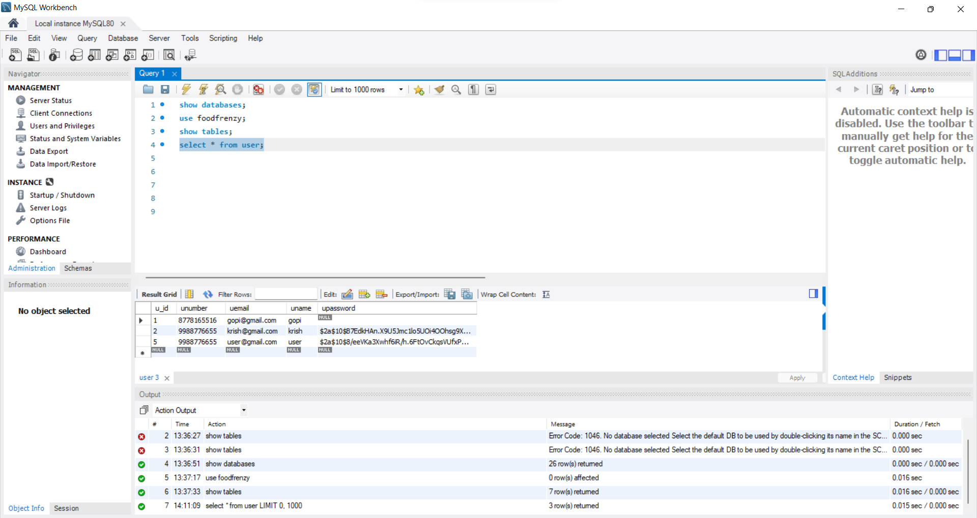

**13.2 Orders Table:**

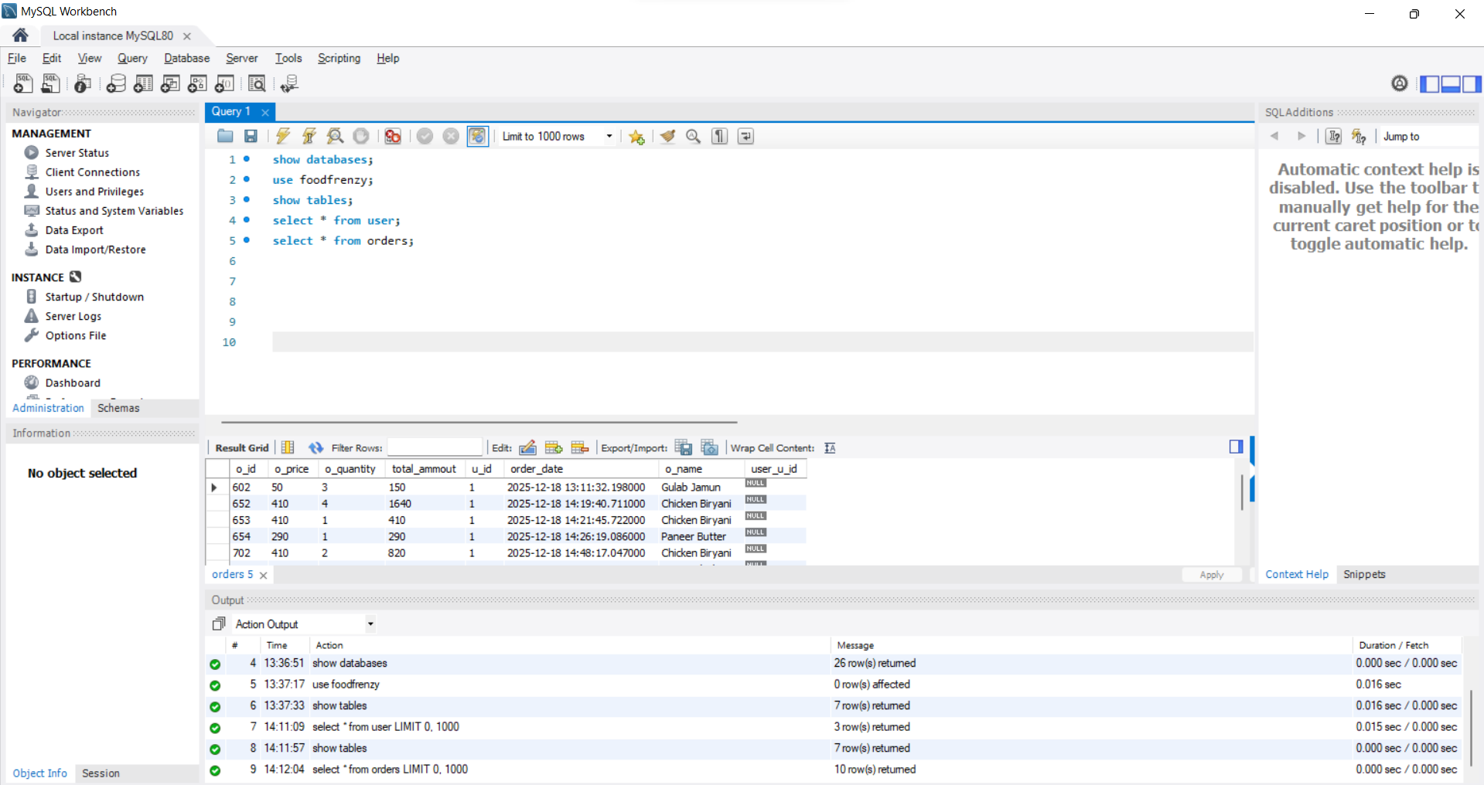

**13.3 Admin Table:**

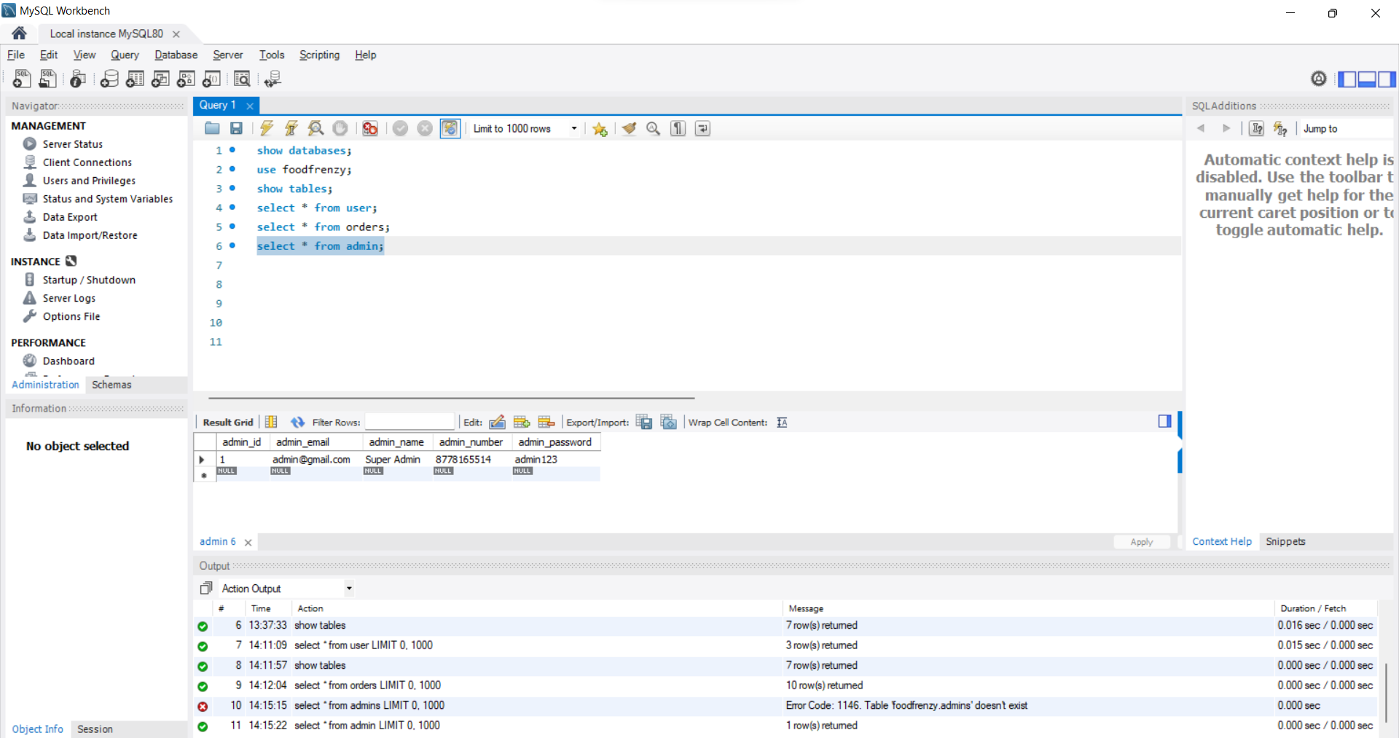

**13.3 Product Table:**

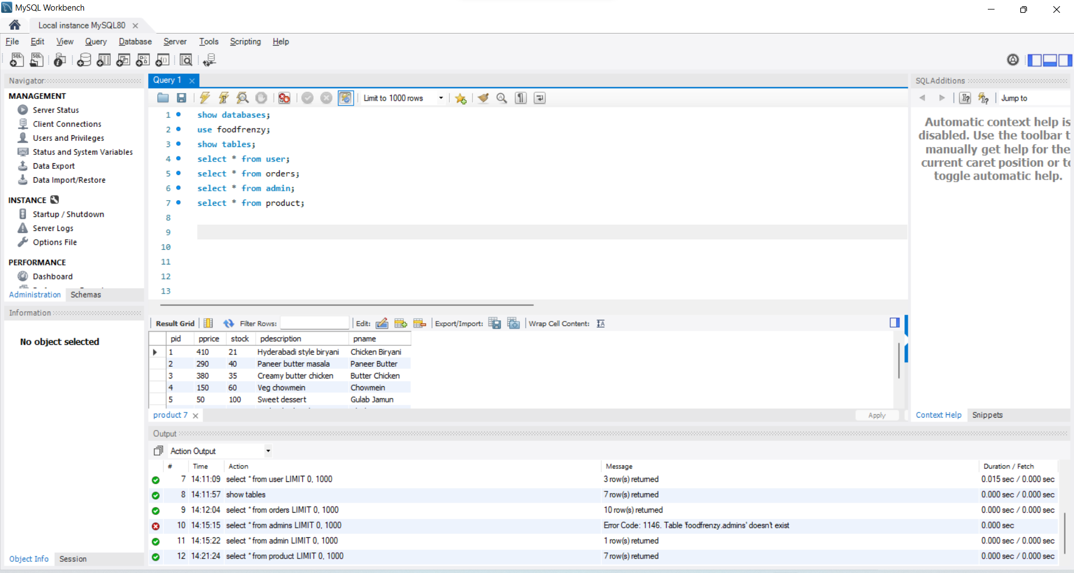

**14.TESTING**

**14.1** **Spring Boot Testing:**

Spring Boot testing plays a crucial role in ensuring the reliability and correctness of the FoodFrenzy application. The project uses Spring Boot’s testing framework to validate different layers of the application, including controllers, services, and repositories. Unit tests are written to verify business logic such as product management, user authentication, stock handling, and order processing. Integration tests help ensure smooth interaction between the application and the database using an in-memory database where required. By using annotations like @SpringBootTest, @WebMvcTest, and @DataJpaTest, the application achieves better code quality, reduces runtime errors, and ensures stable performance before deployment.

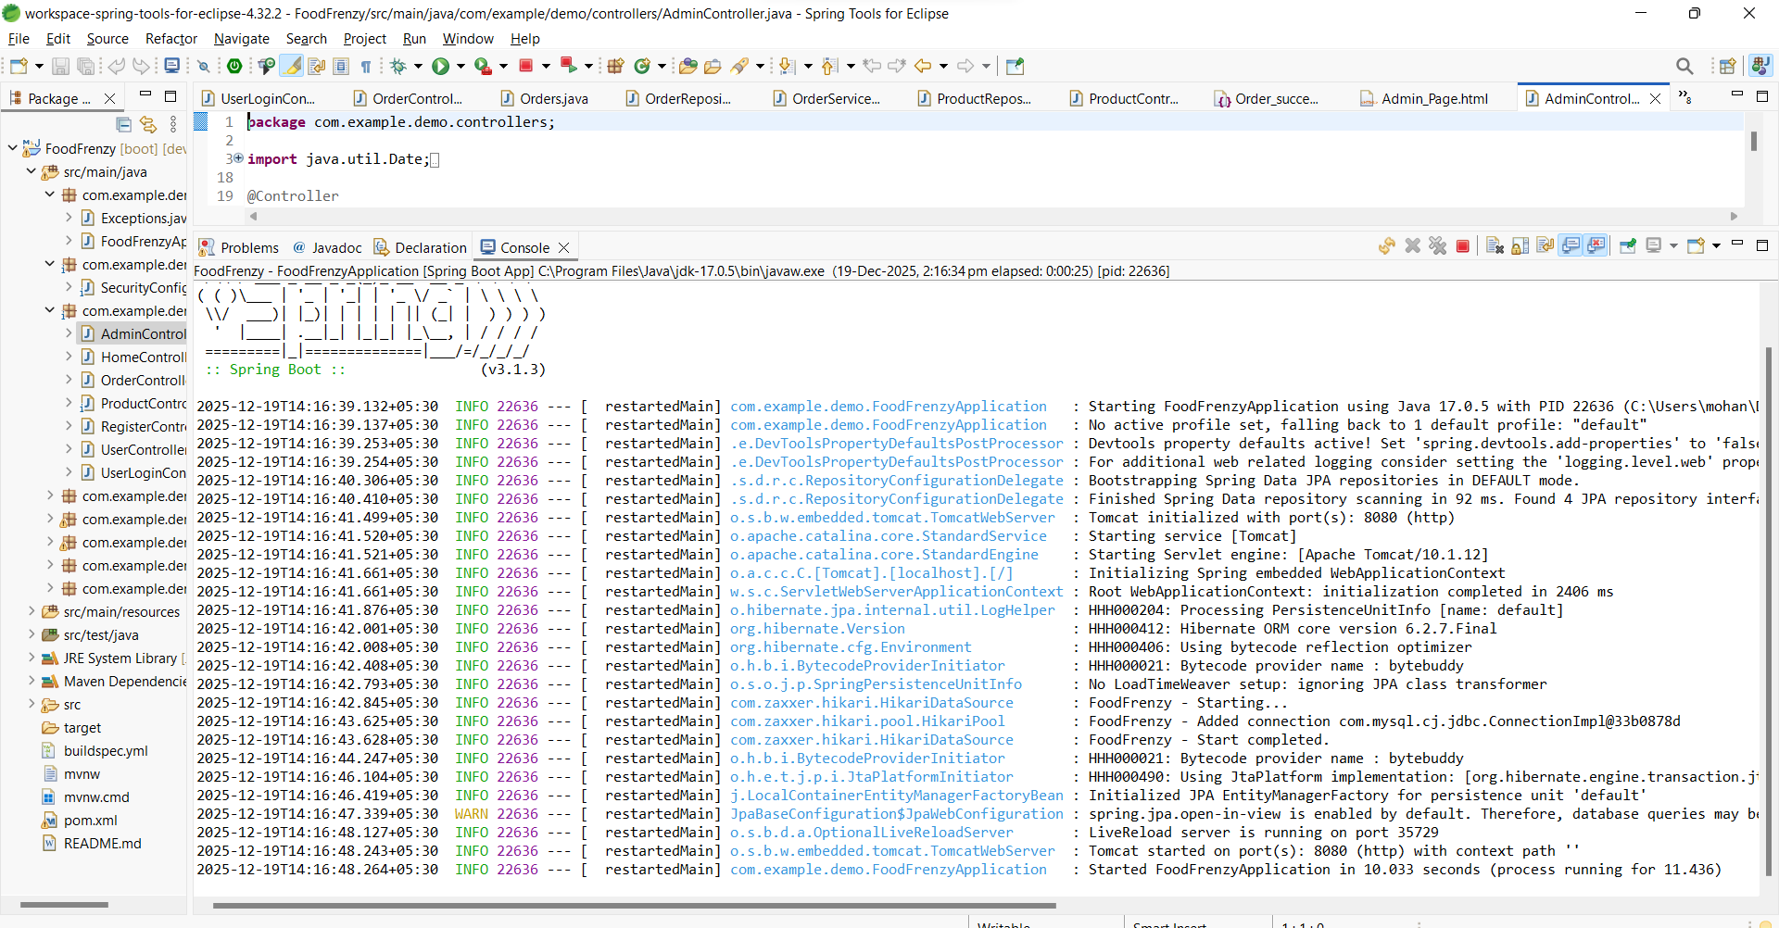

**15.CONCLUSION AND FUTURE ENHANCEMENTS**

**15.1 CONCLUSION:**

The FoodFrenzy project successfully demonstrates the development of a full-stack web application using Java, Spring Boot, Thymeleaf, and MySQL to manage an end-to-end food ordering system. The application provides separate functionalities for administrators and users, enabling efficient product management, stock handling, user management, and order processing. By following a layered architecture and RESTful principles, the system ensures better scalability, maintainability, and security. Overall, this project enhances practical understanding of real-world web application development and serves as a strong foundation for future enhancements such as online payments, order tracking, and advanced analytics.

**15.2 FUTURE ENHANCEMENTS:**

**Online Payment Integration** – Integrate secure payment gateways like UPI, cards, or wallets to enable complete cashless transactions.

**Order Tracking System** – Allow users to track order status in real time (placed, preparing, dispatched, delivered).

**Inventory Alerts** – Automatically notify admins when product stock reaches a low level.

**User Reviews & Ratings** – Enable customers to rate and review products to improve service quality.

**Role-Based Security** – Enhance authentication and authorization using Spring Security and JWT.

**Mobile Application Support** – Develop an Android/iOS app to make the system more accessible and user-friendly.

**Project Video Drive Link:**

https://drive.google.com/drive/folders/1eyMo3-ciOmDeslR957TGhx1srwQ2Rs-O